AI Marketing Operating System (AIMOS)
Marketing Agency

AIMOS – AI Marketing Operating System Business Requirements Document (BRD) Version 2.0 | March 2026 Prepared for: SME Marketing Agency Platform

1. Executive Summary
The AI Marketing Operating System (AIMOS) is a complete no-code AI-powered SaaS platform that automates the entire digital marketing lifecycle for Small and Medium Enterprises (SMEs) and marketing agencies.
It replaces 12 traditional departments with intelligent AI modules that work together seamlessly. Clients can launch full campaigns in under 10 minutes with AI-generated creatives (graphics, videos, voiceovers), automated approvals, publishing to Meta/Google/TikTok, lead capture, AI sales agents, and real-time ROI optimization.
The platform supports three user roles:
- Platform Admin
- Agency / SME Client (the paying user)
- End Customer (SME’s customer)
Key Benefits:
- Reduce campaign creation cost by 70%
- Launch campaigns in <10 minutes
- Fully automated creatives, publishing, and optimization
- Mobile-first dashboard with live analytics

2. Business Objectives
- Automate 100% of campaign creation and launch
- Enable non-technical SMEs to run professional marketing
- Provide AI-generated creatives in 3–10 variations
- Deliver real-time analytics and self-optimizing campaigns
- Generate recurring revenue through subscription + per-campaign fees
- Achieve >99.9% uptime and GDPR compliance

3. Stakeholders
Primary: Platform Owner, Agency/SME Clients, End Customers Secondary: Payment gateways, Social media APIs, AI engines (OpenAI, ElevenLabs, AdCreative.ai, Pictory, etc.)

4. Core System Modules (12 AI Modules as per original vision)
- AI Business Analyzer – Analyzes industry, competitors, audience, pricing → recommends platforms & budget
- AI Brand Builder – Auto-generates logo variations, color palette, brand voice, social templates
- AI Content Studio – Generates graphics (AdCreative.ai), videos (Pictory), voice ads (ElevenLabs)
- AI Campaign Builder – Auto-targeting, budget allocation, launches on Meta/Google
- AI Social Media Manager – Scheduling, posting, engagement tracking
- AI Lead Capture System – Landing pages, forms, WhatsApp chatbot, CRM sync
- AI Sales Agent – 24/7 chatbot that qualifies leads & books appointments
- AI Customer Engagement Engine – Email/SMS/WhatsApp follow-ups, loyalty programs
- AI Analytics Engine – Real-time ROI, CPL, conversions
- AI Optimization Engine – Auto-pauses losers, boosts winners, suggests improvements
- AI Growth Planner – End-of-campaign recommendations for next cycle
- AI Business Dashboard – Mobile-first client interface

5. Transaction Flow (Campaign Creation)
- SME logs in → 2. “Create Campaign” → 3. Enters objective + budget → 4. AI generates 3 creatives → 5. Client approves → 6. Payment → 7. Campaign auto-launches → 8. Live analytics + optimization

6. User Journeys
Agency/SME Client Journey: Sign-up → Link accounts → Campaign brief → AI creation → Approval → Launch → Monitor → AI next steps End Customer (SME’s customer) Journey: See ad → Click → Land on page → Chat with AI sales agent → Purchase → Data feeds back to analytics Admin Journey: Dashboard → Manage users → Monitor campaigns → Billing → Compliance → Analytics

7. Wireframes & High-Fidelity Designs
(Reference the realistic mobile wireframes and flowcharts I generated for you earlier — Admin Login/Dashboard, Agency Campaign Creation, Creative Approval, Analytics, etc. All are mobile-first iPhone frames.)

8. Technology Recommendation (No-Code Path)
- Frontend + Backend: Bubble.io (2026 version with built-in AI generator)
- Database: Built-in Bubble DB (PostgreSQL-level)
- AI Integrations: OpenAI/Claude + ElevenLabs + AdCreative + Pictory APIs
- Payments: Stripe
- Hosting: Bubble cloud (99.9% uptime)

9. Security & Compliance
- Role-based access, MFA, encrypted payments, GDPR-ready

10. Success Metrics
- Campaign creation <10 min
- AI creative generation <60 sec
- Onboarding <5 min

11. Future Enhancements
- Auto-budget optimizer, WhatsApp campaigns, AI influencer module, predictive ROI
Appendix: Full 12-module details, transaction diagrams, and user flows (included in the doc version).

Admin Role Wireframes
Admin Login Screen
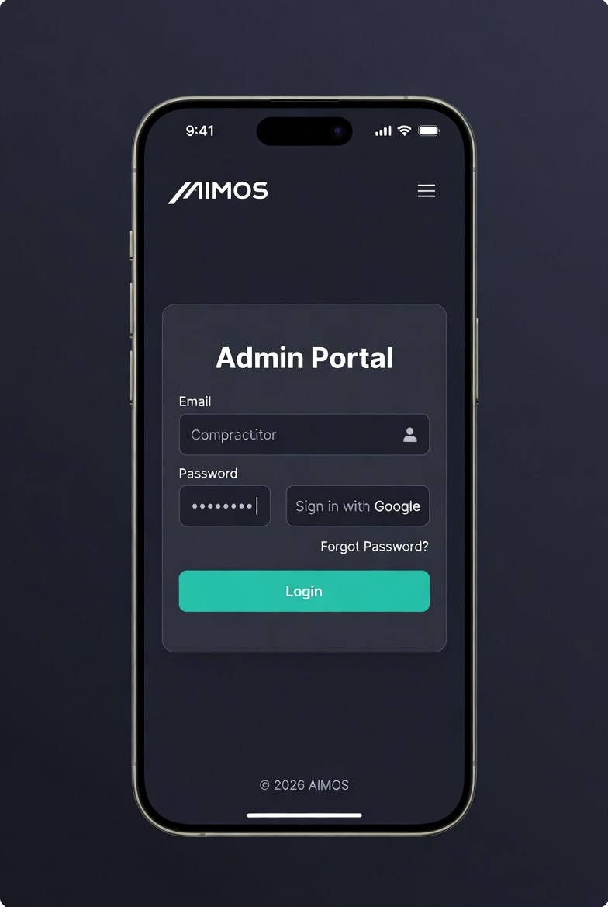

Admin Dashboard
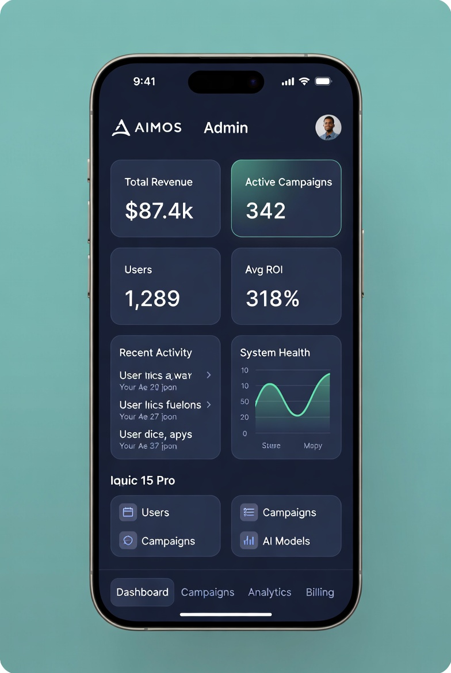

User (Agency/SME) Management Screen
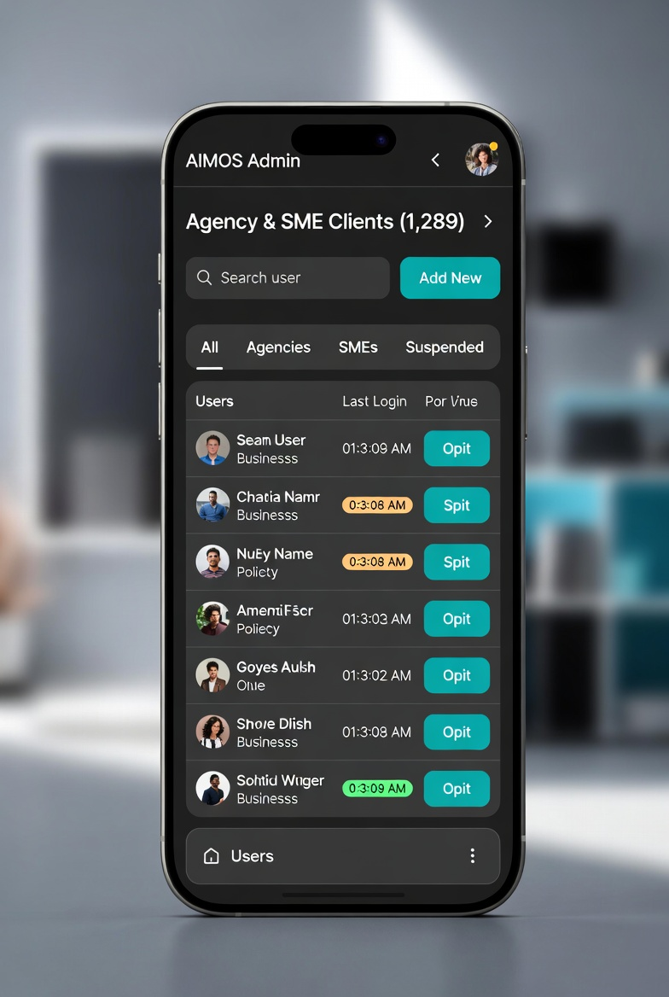

Platform Analytics Screen
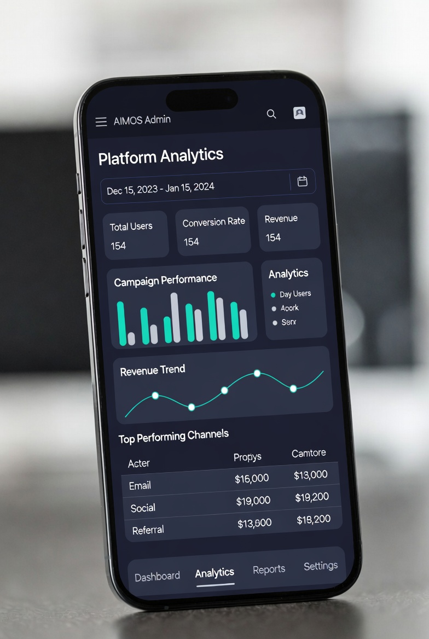

User (Agency) Role Wireframes
Agency User Dashboard
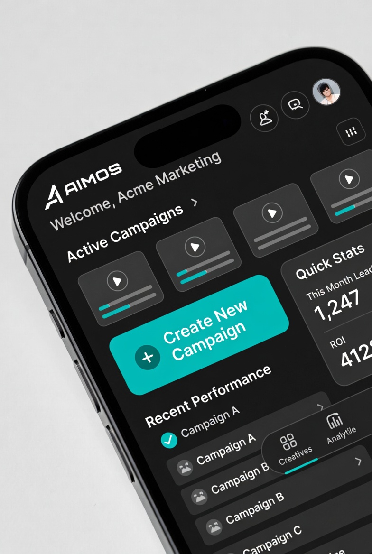
Campaign Creation Screen
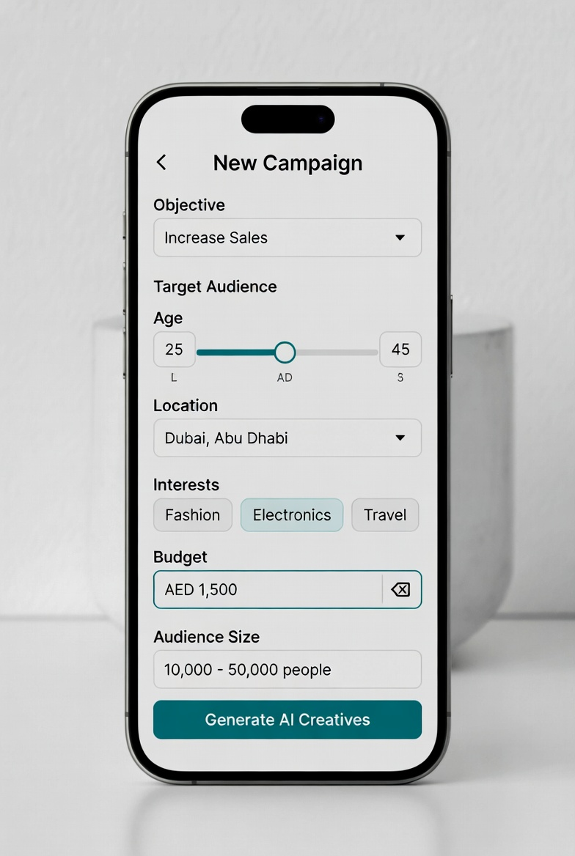

Creative Approval Screen
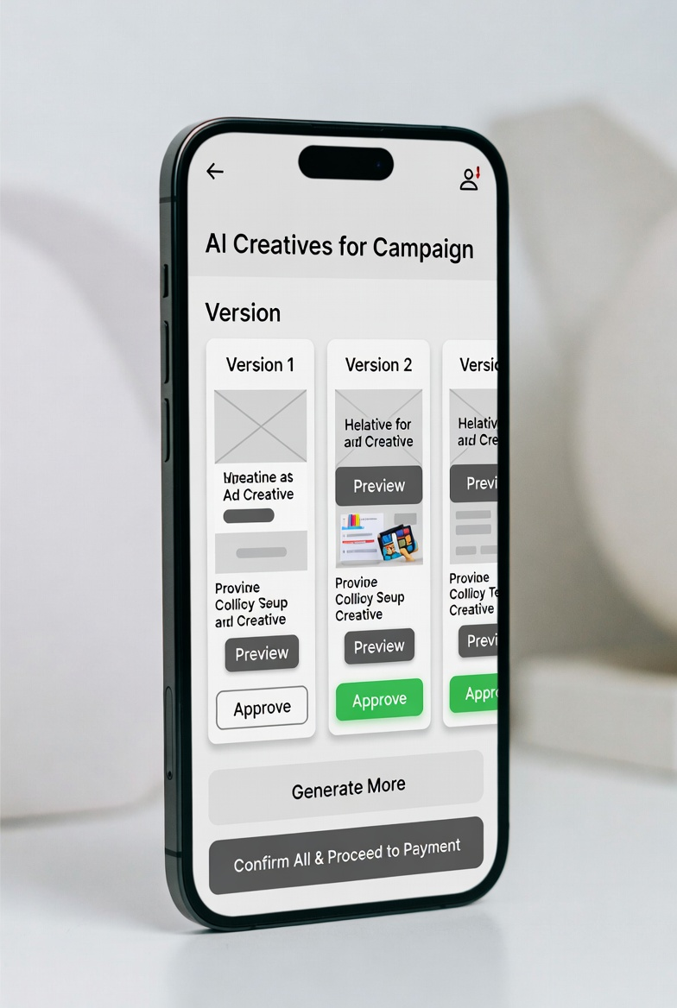

There are going to be 12 AI Modules working together, each module replaces a typical department in a marketing company.

Client Onboarding
↓
AI Strategy Engine
↓
Content Generation
↓
Campaign Launch
↓
Lead Capture
↓
AI Sales Agent
↓
Customer Engagement
↓
Analytics & Optimization
↓
Next Campaign Planning

1. AI Business Analyzer
This module studies the client’s business automatically.
It analyzes:
- industry
- competitors
- location
- audience demographics
- pricing strategy
AI tools like ChatGPT or Claude AI can generate the initial marketing strategy.
Output example:
- best social platforms
- recommended ad budget
- content themes

2. AI Brand Builder
Creates the brand kit automatically.
Output:
- logo variations
- color palette
- social templates
- brand voice
Tools often used:
- Canva
- Looka
This is especially useful for new SMEs with no branding.

3. AI Content Studio
This module generates marketing assets automatically.

Graphics
Using tools like
AdCreative.ai
Creates:
- social posts
- ad creatives
- banners

Video
Using
Pictory AI
Creates:
- Instagram reels
- TikTok videos
- YouTube shorts

Voice Ads
Using
ElevenLabs
Creates:
- radio ads
- narration
- promotional voiceovers
Your platform can produce 3–10 variations of each creative.

4. AI Campaign Builder
Automatically launches campaigns.
Platforms supported:
- Meta Ads Manager
- Google Ads
AI selects:
- audience targeting
- campaign objectives
- ad placements
- budget allocation
This replaces a human media buyer.

5. AI Social Media Manager
Handles publishing across social networks.
Tools like:
- Buffer
- Hootsuite
Functions:
- content scheduling
- hashtag optimization
- posting calendar
- engagement tracking

6. AI Lead Capture System
Converts visitors into leads.
This module includes:
- landing pages
- forms
- WhatsApp integration
- chatbot
Platforms commonly used:
- GoHighLevel
Leads are automatically stored in a CRM.

7. AI Sales Agent
One of the most powerful modules.
AI chatbots can:
- respond to inquiries
- qualify leads
- book appointments
- recommend products
Chat automation tools include:
- ManyChat
- Tidio
This creates 24/7 automated sales support.

8. AI Customer Engagement Engine
Keeps customers engaged after purchase.
Channels include:
- email marketing
- SMS campaigns
- WhatsApp messages
- loyalty rewards
Automation tools include:
- Mailchimp
This module helps increase repeat sales.

9. AI Analytics Engine
Tracks campaign performance in real time.
Metrics include:
- impressions
- click-through rate
- cost per lead
- conversions
- ROI
Analytics platforms:
- Google Analytics
- Looker Studio

10. AI Optimization Engine
Automatically improves campaigns.
The system can:
- pause low-performing ads
- increase budget for successful creatives
- change targeting
- suggest better posting times
This creates self-optimizing marketing campaigns.

11. AI Growth Planner
At the end of every campaign cycle, AI recommends the next plan.
Example recommendation:
Best performing channel: Instagram
Best content type: video reels
Best audience: women 25–35
Recommended next step:
Increase Instagram ad spend by 30%
Launch TikTok campaign
This makes the platform behave like a marketing consultant.

12. AI Business Dashboard
The client interface (mobile-first).
This dashboard shows:
- campaigns
- approvals
- leads
- sales
- marketing ROI

1. Executive Summary
The AI Marketing Operating System (AIMOS) is a platform designed for Small and Medium Enterprises (SM
to automate their digital marketing lifecycle using Artificial Intelligence.
The platform captures marketing requirements, generates AI-based creatives (video, audio, graphics),
gets approvals from clients, and publishes campaigns across multiple digital channels automatically.
The system supports a three-layer user structure:
1. Platform Admin
2. SME Client (User)
3. SME Customer (User’s User)
The system will integrate content generation AI models, approval workflows, campaign scheduling,
payment gateways, and analytics engines.

2. Business Objectives
• Automate digital marketing campaign creation
• Reduce campaign creation cost by 70%
• Enable SMEs to launch campaigns within 10 minutes
• Provide automated AI-generated creatives
• Enable campaign approval workflows
• Publish campaigns to multiple social media channels
• Provide ROI-based campaign analytics

3. Stakeholders
Primary Stakeholders
• Platform Owner
• SME Business Clients
• SME Customers
• Marketing Agencies
Secondary Stakeholders
• Payment gateway providers
• Social media APIs
• AI content generation engines

4. System Modules
1. User Onboarding Module
2. Campaign Requirement Capture Engine
3. AI Creative Generation Engine
4. Approval Workflow System
5. Campaign Publishing Engine
6. Payment Processing Engine
7. Analytics & Reporting Engine
8. Admin Control Center

5. Transaction Flow – Campaign Creation
Step 1 – SME logs into platform
Step 2 – Clicks "Create Campaign"
Step 3 – Enters campaign objective
Step 4 – AI generates 3 variations of creatives
Step 5 – SME reviews and selects preferred creative
Step 6 – SME approves campaign
Step 7 – Payment processed
Step 8 – Campaign scheduled for publishing
Step 9 – Campaign pushed to social media APIs
Step 10 – Analytics collected and displayed

6. Transaction Flow Diagram
SME USER
|
v
Campaign Request
|
v
AI Content Generator
|
v
3 Creative Versions Generated
|
v
Client Approval
|
v
Payment Gateway
|
v
Campaign Scheduler
|
v
Social Media Publishing
|
v
Analytics Dashboard

7. User Journey – SME Client
1. Sign Up
2. Business Verification
3. Social Media Account Linking
4. Campaign Requirement Entry
5. AI Creative Generation
6. Campaign Approval
7. Payment Processing
8. Campaign Launch
9. Performance Analytics
8. User Journey – SME Customer (User's User)
1. View social media advertisement
2. Click call-to-action
3. Visit SME landing page
4. Engage with product or service
5. Complete purchase or inquiry
6. Data captured in analytics system

9. Admin Journey
1. Monitor system activity
2. Manage SME accounts
3. Manage AI models
4. Review campaign compliance
5. Manage billing and subscriptions
6. Review platform analytics

10. Wireframe – SME Dashboard
-------------------------------------------------
| AI MARKETING OS |
-------------------------------------------------
| Create Campaign | Analytics | Billing | Help |
-------------------------------------------------
| Active Campaigns |
|------------------------------------------------|
| Campaign 1 | Status | Budget | Performance |
| Campaign 2 | Status | Budget | Performance |

11. Wireframe – Campaign Creation Screen
-------------------------------------------------
| Campaign Objective |
| [ Increase Sales ] |
-------------------------------------------------
| Target Audience |
| Age | Location | Interests |
-------------------------------------------------
| Budget Input |
| [ AED 500 ] |
-------------------------------------------------
| Generate AI Creatives Button |

12. Wireframe – Creative Approval Screen
-------------------------------------------------
| AI Generated Creative Options |
-------------------------------------------------
| Version 1 | Preview | Approve |
| Version 2 | Preview | Approve |
| Version 3 | Preview | Approve |
-------------------------------------------------
| Final Approval |

13. Payment Transaction Flow
SME Approves Campaign
|
vPayment Gateway Triggered
|
v
Card / Wallet / Bank Payment
|
v
Payment Confirmation
|
v
Campaign Activated

14. Technology Architecture
Frontend: React / Next.js
Backend: Node.js / Python AI services
AI Engines: Open-source LLM + Media Generation Models
Database: PostgreSQL
Cloud Infrastructure: AWS / GCP
Storage: S3-compatible media storage

15. Security Requirements
• Role-based access control
• Encrypted payment processing
• Secure API integrations
• GDPR compliant data handling
• Multi-factor authentication

16. Success Metrics
• Campaign creation time < 10 minutes
• AI creative generation < 60 seconds
• SME onboarding < 5 minutes
• Platform uptime > 99.9%

17. Future Enhancements
• AI auto-budget optimizer
• Voice-based campaign creation
• WhatsApp campaign integration
• AI influencer marketing module
• Predictive campaign ROI engine

